Kloudrac Exam – 15.03.2021

# Multiple choice Questions

1. 4
2. 1,2,3&4
3. 2
4. 2
5. 1
6. 2
7. 3,4
8. 4
9. 3
10. 4
11. 4
12. 1,3&4
13. 3
14. 2
15. 2
16. 2&3
17. 1
18. 2
19. 4
20. 4

# Validation Rules

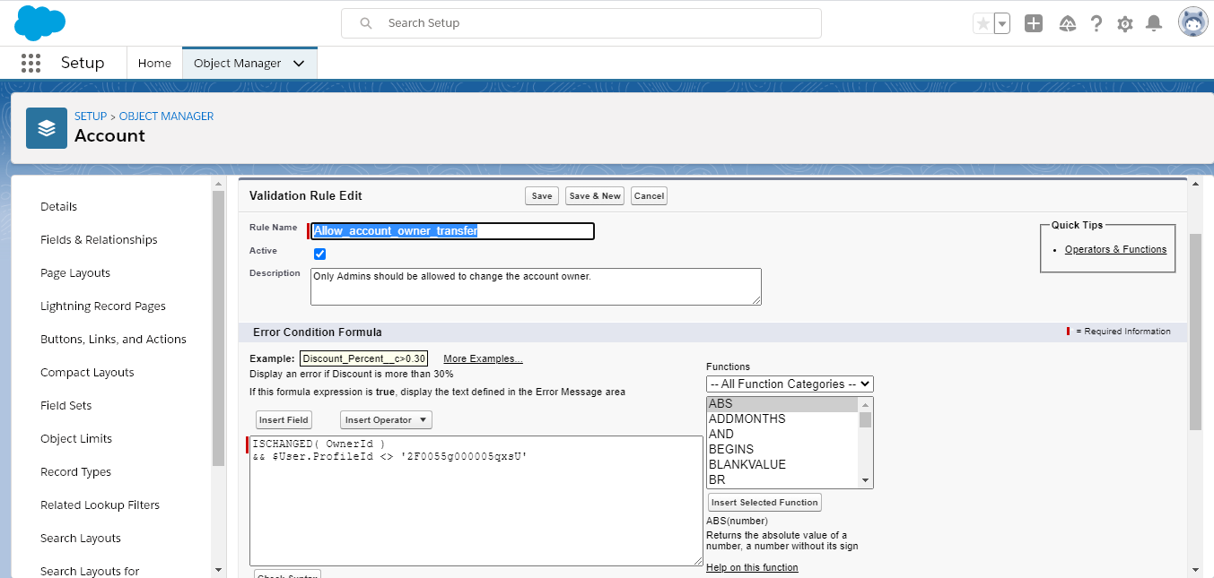

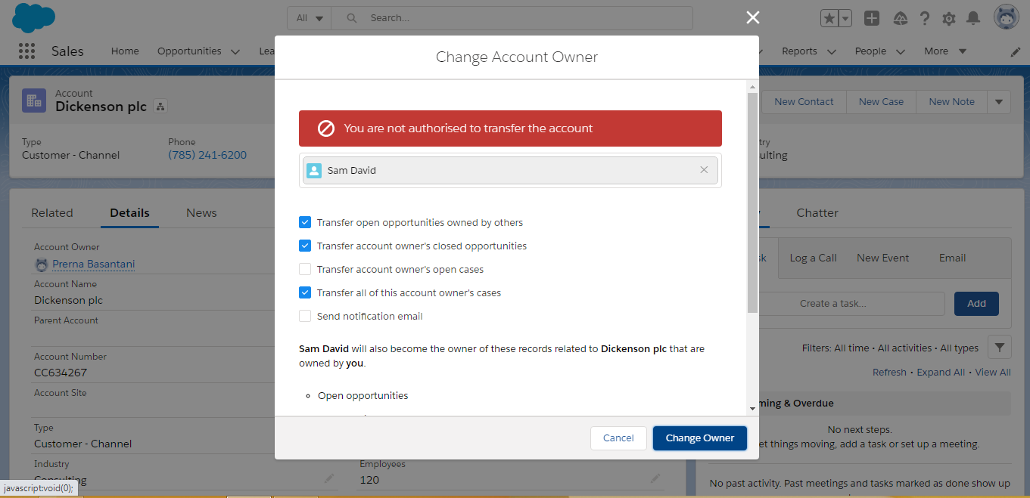

1. 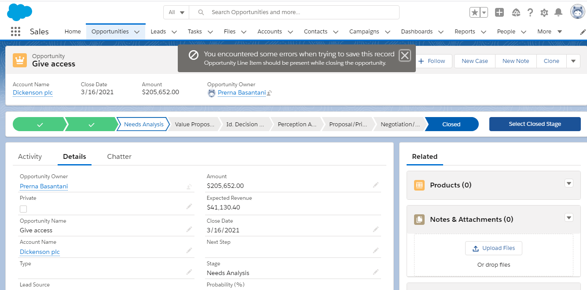

# Workflow Rules

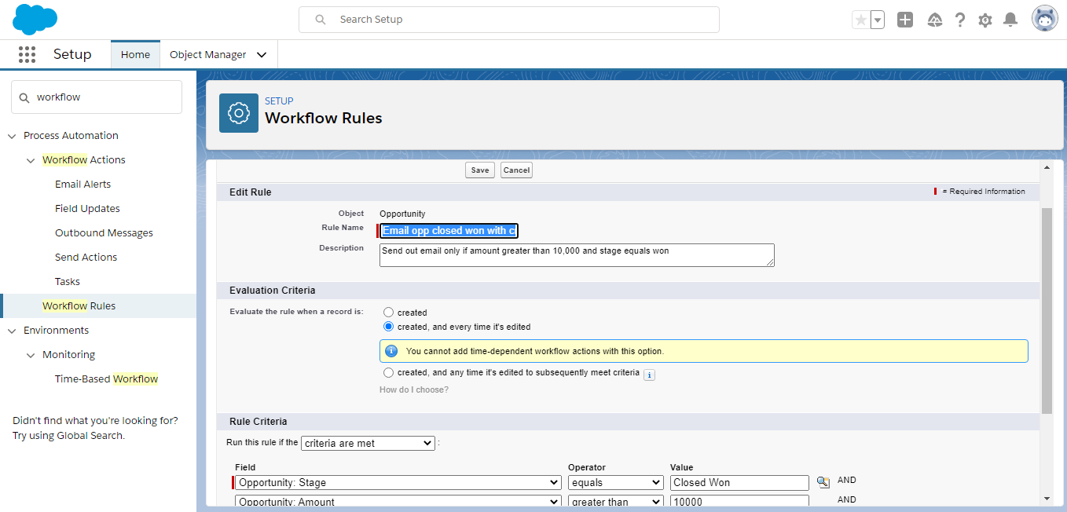

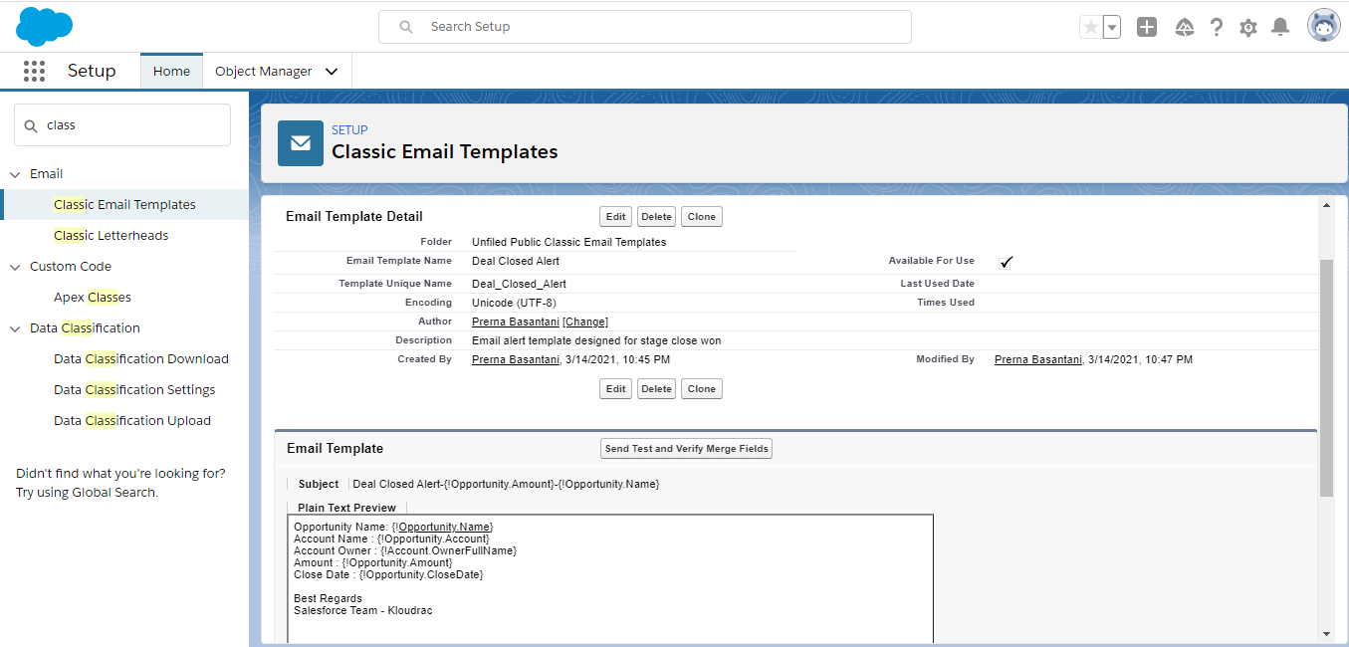

# Process Builder

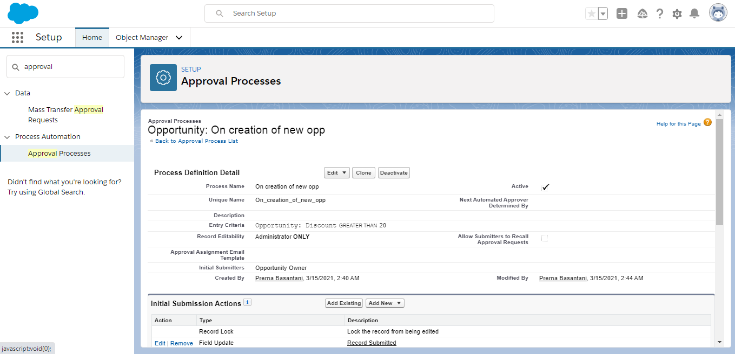

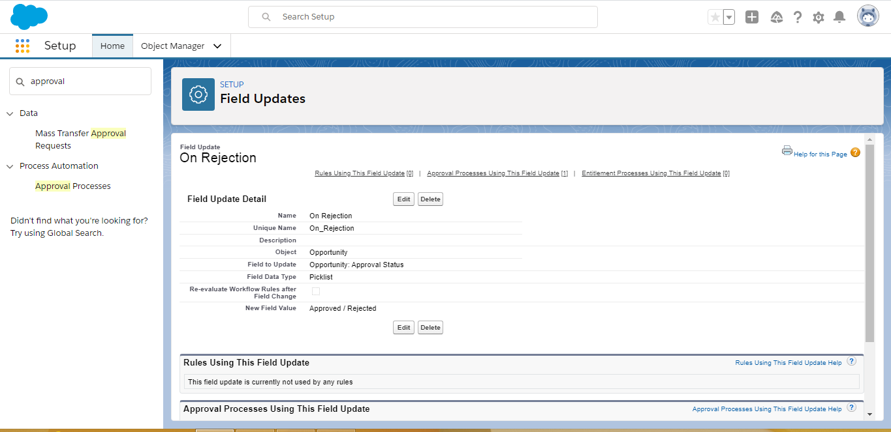

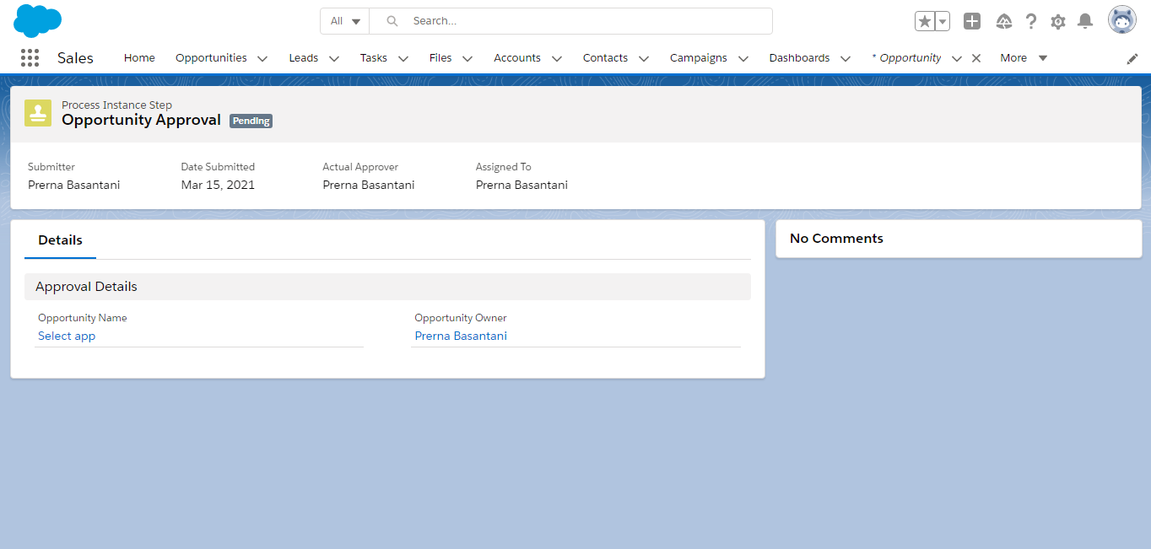

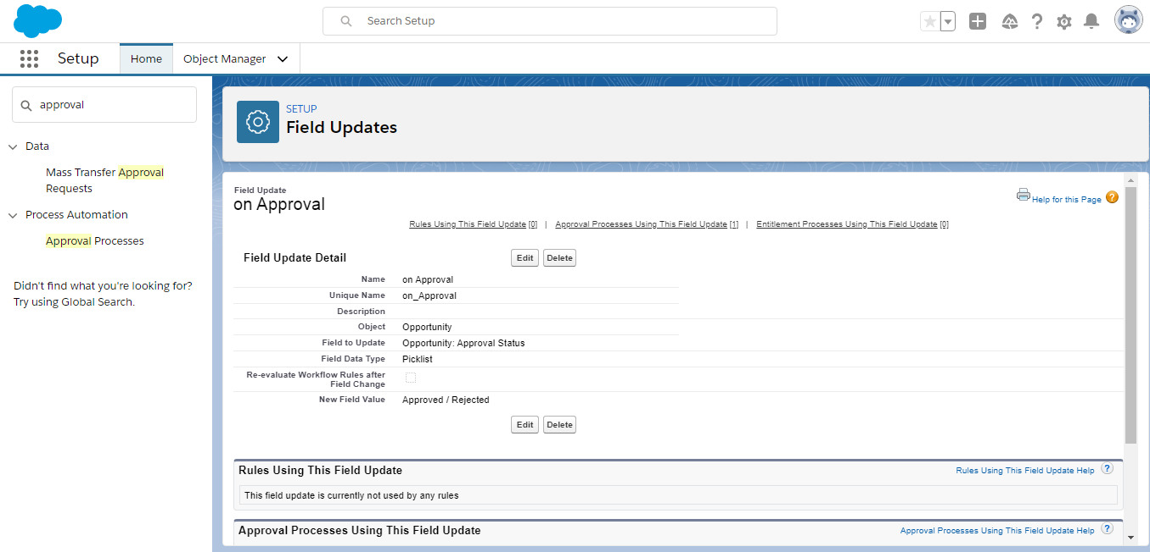

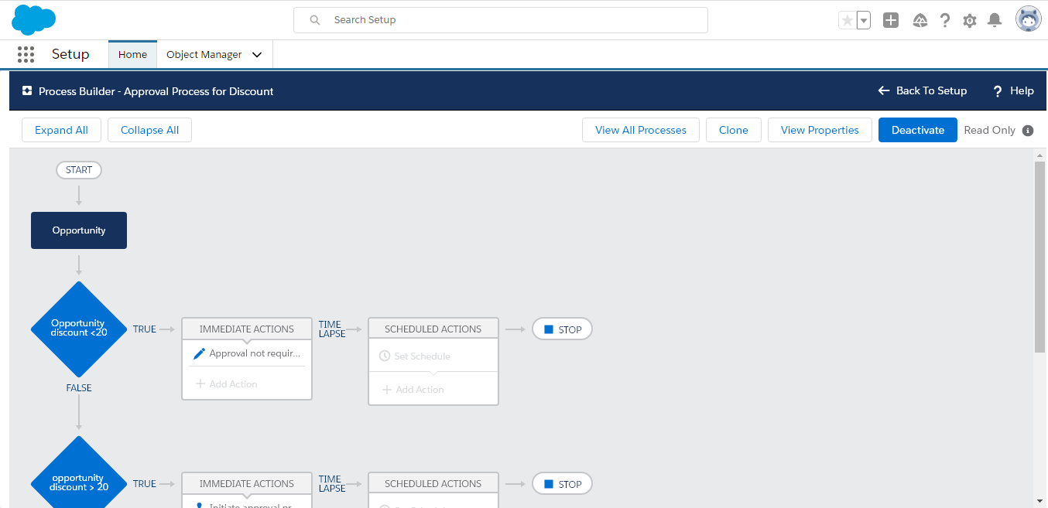

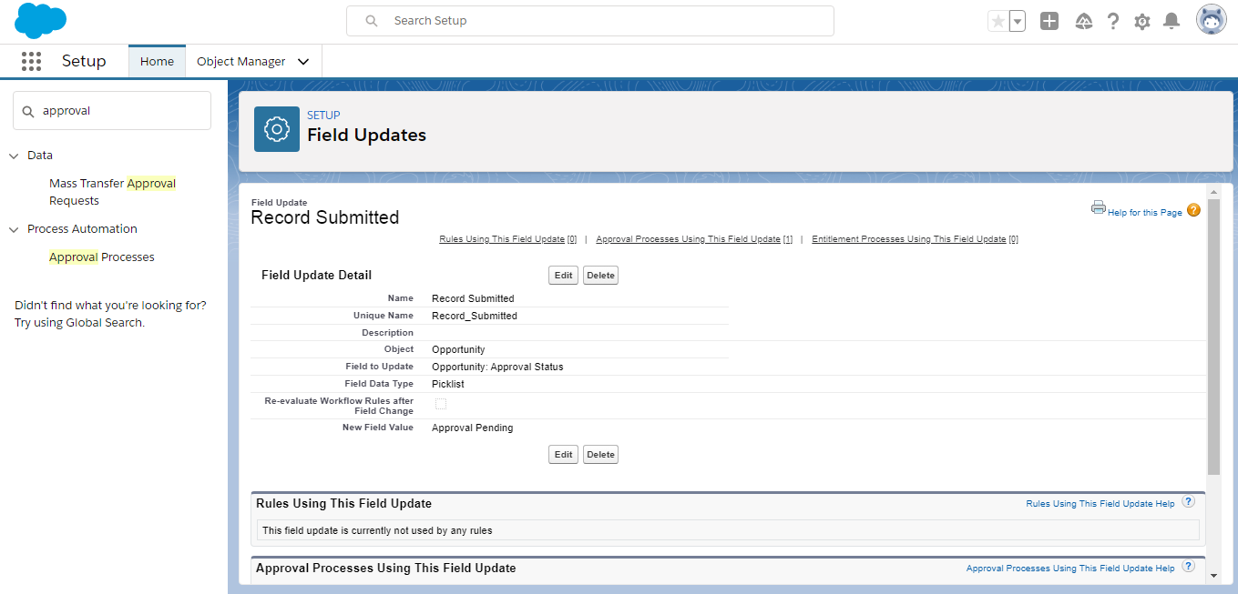

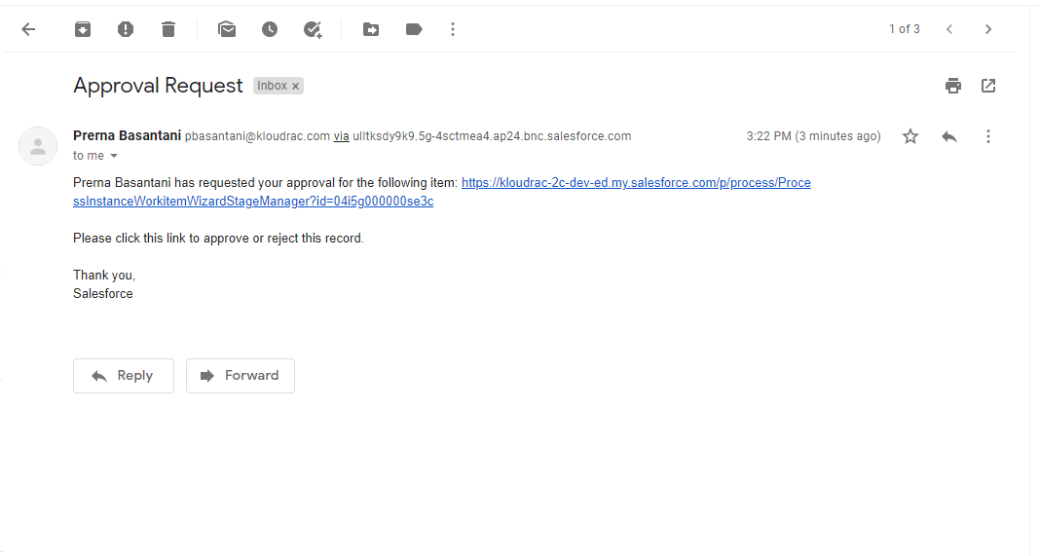

# Triggers

Trigger quote on Quote (after insert, after update, after delete, after undelete) { if(Trigger.isinsert || Trigger.isupdate || trigger.isdelete || Trigger.isundelete){ countNumberOfQuoteLineItems.countNumberOfQuoteLineItems(trigger.new,trigger.old); }  
}

Class

public inherited sharing class quoteline {

public quoteline(List<Quote> newQuote,List<Quote> oldQuote) {

set<id> accids= new set<id>();

try{

if(newQuote !=null){

for(Quote q:newQuote){

if(q.AccountId!=null){

accids.add(q.accountid);

}

}

}if(oldQuote!=null){

for(Quote q:oldQuote){

accids.add(q.accountid);

}

}

List<Account> acc = [Select id, NoofQuoteLineItem__c,(Select id from Quote) from Account where id IN: accids];

Map<Id, Integer> accCountMap = new map<Id, Integer>();

List<AggregateResult> AggregateResultList = [Select AccountId, SUM(Number_of_quote_line_Item)noOfLienItem FROM Quote Where AccountId IN: accids Group BY AccountID]

if(AggregateResultList != null && AggregateResultList.size() > 0){

for(AggregateResult aggr:AggregateResultList){

accCountMap.put(aggr.get(AccountID),aggr.get(noOfLienItem) );

}}if(acc!=null){

for(Account accValue:acc){

accValue.NoofContacts__c = accCountMap.get(accValue.id);

}

}

if(!acc.isempty()){

update acc;

}

}

catch(exception e){

System.debug('Get Message'+e.getMessage());

} }

}